**Department of Electrical and Electronic Engineering**



Embedded Systems Project 2025-26

DESIGN REPORT 1

Title: ?

Group Number: ?

|  |  |  |  |
| --- | --- | --- | --- |
| Group members: | ID Number | I confirm that I authored this document and am eligible for a grade | I confirm that this is the group’s own work. |
|  |  |  |  |
|  |  |  |  |
|  |  |  |  |
|  |  |  |  |
|  |  |  |  |

Tutor: Click here to enter text.

Date: Click here to enter a date.

Contents

1. Introduction 1

2. Motor characterisation 1

3. Load measurements 1

4. Gear ratio selection 2

5. Summary 2

6. References 2

# Introduction

All your reports should be written in size 12 Arial font, with left aligned text. Please do not change the margins or the spacing in this template.

For more information about the report template:

* See the chapter on Reports (near the start of the ESP Procedures Handbook).
* See the specific marking scheme for this section of the report.

You may want to reference books and papers that you have researched. Give their reference like this [1] (see the References section at the end of this document). Remember that all references must follow the IEEE format.

You will also find it necessary to include figures in your reports, much like Figure 1 below. Please note that the figure has a label and caption; these are both essential. It is also important to note that when you include a figure in your report, you must refer to it somewhere in the body text of your report.

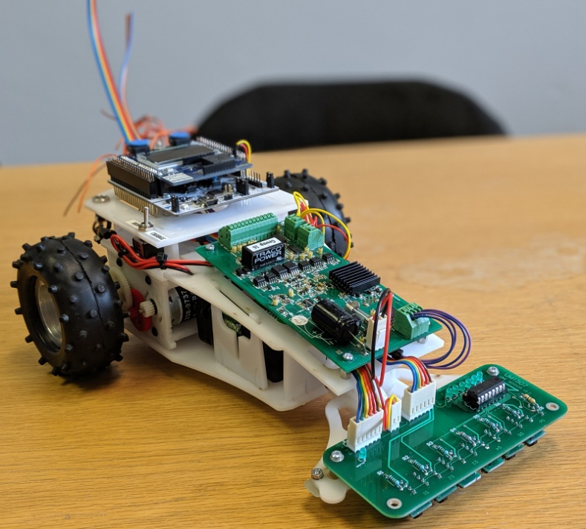

Figure 1 – Graphic of ESP buggy

You should only include figures if they are relevant to your report, and if they are displayed clearly. Any unnecessary figures, or ones which are not properly displayed (e.g. ones that are too small to see clearly) may result in a marking penalty.

# Motor characterisation

* See the chapter on Reports (near the start of the ESP Procedures Handbook).
* See the specific marking scheme for this section of the report.

# Load measurements

* See the chapter on Reports (near the start of the ESP Procedures Handbook).
* See the specific marking scheme for this section of the report.

# Gear ratio selection

* See the chapter on Reports (near the start of the ESP Procedures Handbook).
* See the specific marking scheme for this section of the report.

# Summary

* Design recommendations
* Summary of key results and assumptions.

# References

1. See the section ‘Reports’ in in the “Project Information, Rules and Procedures” section on Canvas.

Make sure that you have **read the top** of the marking scheme to look for report length etc.

Make sure that you have **read the bottom** of the marking scheme for Presentation and Penalties.

Remember to update your table of contents before submitting the report.

Aim to submit the report long before the deadline, to mitigate last minute problems with the internet and with Canvas.